Číslo šablony: III/2

VY_32_INOVACE_P1_3.6

**Tematická oblast: Exercises for Maturita Solutions Pre-Intermediate**

**PERSONALITIES**

Typ: DUM – pracovní list

Předmět: Anglický jazyk

Ročník: 3. a 6. r. (6leté), 1. a 4. r. (4leté)

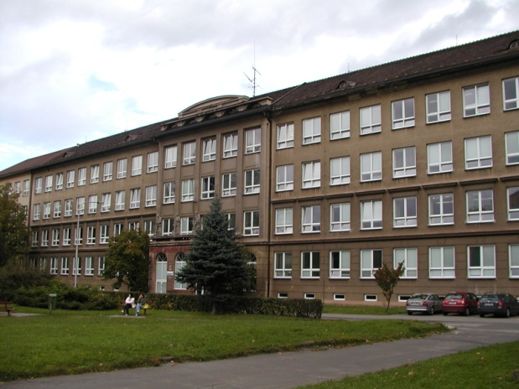

Zpracováno v rámci projektu

EU peníze školám

CZ.1.07/1.5.00/34.0296

Zpracovatel:

**Mgr. Vilma Sikorová**

Gymnázium, Třinec, příspěvková organizace

Datum vytvoření: **březen 2014**

**Metodický list**

Pracovní list je určen k procvičování a upevňování slovní zásoby na téma **Osobnost.**   
Lze s ním pracovat jak formou samostatné práce žáků, tak formou práce ve dvojicích  
a ve skupinách.  
 **Cvičení 1 – 5** se věnují popisu zevnějšku lidí, tzn. jejich celkového vzhledu, postavy, vlasů, zvláštních rysů a věkových skupin.   
 **Cvičení 6 a 8** upevňují slovní zásobu pro popis charakteru osobnosti a rozvíjejí znalost protikladných vlastností.   
  
**Cvičení 7** prověřuje znalost vlastností člověka formou definicí – P / N (true/false).  
I když byl DUM vytvořen jako pracovní list k učebnici **Maturita Solutions  
Pre-Intermediate,** lze jej využít i v jiných skupinách žáků jako podklad pro rozvíjení řečových dovedností na dané téma a jeho opakování.  
   
Součástí DUMu je správné řešení pro jednotlivá cvičení s výjimkou cvičení 5, které vyžaduje vlastní odpovědi žáků.

**DESCRIBING PEOPLE´S APPEARANCE AND AGE  
  
1) Write the following words into the right box.***broad shoulders beautiful tall slim middle-aged elderly ginger plain fat young handsome short birthmark skinny scar beard good-looking spiky overweight blonde straight wrinkles stocky pretty muscular tattoo curly of average height plump moustache pensioner freckles   
physically attractive dark old well-built wavy thin medium height   
in his/her (early/late) twenties grey bald*

|  |  |
| --- | --- |
| GENERAL |  |
| HEIGHT |  |
| BUILD |  |
| HAIR |  |
| AGE |  |
| SPECIAL FEATURES |  |

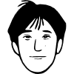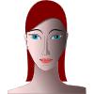**[](http://www.clker.com/clipart-9840.html)[](http://www.clker.com/clipart-9467.html)**

**2) Complete these sentences in a suitable way.  
 (More than one answer may be possible.)** 1. I´ve got straight black …………… and I´m quite tall and very ……………   
 2. Lucy has got very pale …………… .  
 3. Both men were good-………….. and …………… .  
 4. She´s beautiful but her younger sister is really …………… .  
 5. He´s got very muscular …………… .  
 6. Her boyfriend has very …………… shoulders.  
 7. Most women don´t like men with hairy …………… .  
 8. Peter looks attractive. He has grown a …………… .   
  
  
**3) What questions do you need to ask about the following?** a) someone´s general appearance ***What*** ………………………………...?  
 b) their height ***How*** …………………………………?  
 c) their weight ***How much*** …………………………..?   
 d) their character ***What*** ………………………………. ..?

**4) What stage of life are these people at?   
 Choose the correct word from the box.**

*get divorced an adult old age a generation retired*

*a toddler late forties a baby a teenager adolescence*

1. Ann isn´t two yet, so she´s still …………………………… .  
 2. Sam is eighteen this year, so legally he becomes ………………………… .  
 3. 15 is often a difficult age for boys and girls going through ……………… .  
 4. Our son is only 6 months old, so he´s ……………………………. .  
 5. Caroline is 48, so she´s now in her …………………………… .  
 6. Rebecca is 13 this year, so she´ll soon be ………………………….. .  
 7. When you are in your seventies and eighties, it is called ………………… .   
 8. A group of people of a similar age are ………………………… .  
 9. My father was a doctor but he stopped working a year ago, so he is now  
 …………………………. .  
10. If you stop being married, you ……………………………. .   
  
**5) Describe the people in the pictures.   
 Say more about their general appearance and age.**

**[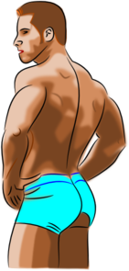](javascript:edit(263322))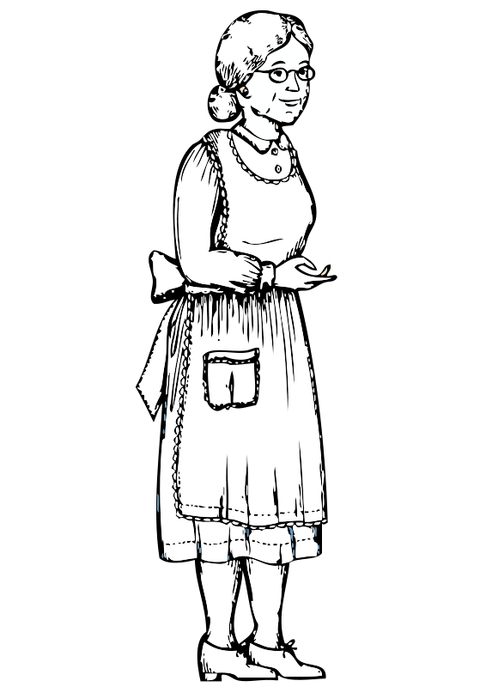***[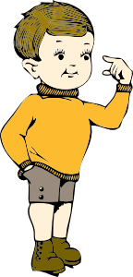](javascript:edit(9347))***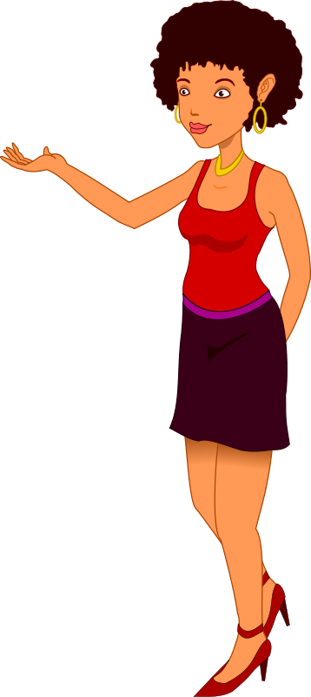**

**DESCRIBING CHARACTER  
6) Organise these words into pairs of opposites and put them into the  
 columns below.** *generous stupid lazy shy clever cheerful mean  
 tense miserable easy-going outgoing hard-working*

POSITIVE NEGATIVE  
 ………………………… ………………………….  
 ………………………… ………………………….  
 ………………………… ………………………….  
 ………………………… ………………………….  
 ………………………… ………………………….  
 ………………………… ………………………….

**7) Is the description correct? Write true or false. (T / F)** 1. Peter´s always buying me little presents. He is very *thoughtful*. _______ 2. If you are *confident*, you don´t think you are very good at things. _______3. A *modest* person talks about themselves a lot. _______  
 4. He´s so *absent-minded*. He keeps forgetting where he has put things. ____  
 5. A *selfish* person cares about the feelings of other people. _______  
 6. Mark isn´t too *agressive*. He keeps getting into fights. _______  
 7. Julie´s always looking in the mirror. She´s so *vain*. _______   
 8. If you´re *over-ambitious*, you don´t really want to do much with your life.  
 _______

**8) What prefix forms should you put opposite of each of these words?   
 (Add *un*, *dis*, *in* or *im*.)**…… kind ……friendly ……honest  
…… reliable …… pleasant …… flexible  
…… patient …… ambitious …… selfish  
…… tolerant …… sensitive …… mature

**Řešení:**  
1)

|  |  |
| --- | --- |
| GENERAL | physically attractive, beautiful, handsome, plain, pretty, good-looking |
| HEIGHT | of average height, tall, short, medium height |
| BUILD | stocky, plump, slim, thin, skinny, fat, overweight, well-built, muscular |
| HAIR | blonde, straight, ginger, wavy, curly, spiky, dark, grey |
| AGE | young, middle-aged, elderly, old, pensioner, in his/her (early/late) twenties |
| SPECIAL FEATURES | broad shoulders, birthmark, bald, scar, tattoo, moustache, wrinkles, freckles, beard |

**2) Possible answers:**  
  
1. I´ve got straight black hair and I´m quite tall and very slim / thin.   
 2. Lucy has got very pale skin.  
 3. Both men were good-looking and well-built / strong.  
 4. She´s beautiful but her younger sister is really plain.  
 5. He´s got very muscular legs /arms.  
 6. Her boyfriend has very broad shoulders.  
 7. Most women don´t like men with hairy chests.  
 8. Peter looks attractive. He has grown a beard / moustache.

**3)**a) *What* does he / she look like?  
b) *How* tall is he / she?  
c) *How much* does he / she weigh?  
d) *What* is he /she like?   
  
  
**4)**  
 1. Ann isn´t two yet, so she´s still a toddler.  
 2. Sam is eighteen this year, so legally he becomes an adult.  
 3. 15 is often a difficult age for boys and girls going through adolescence.   
 4. Our son is only 6 months old, so he´s a baby.  
 5. Caroline is 48, so she´s now in her late forties.   
 6. Rebecca is 13 this year, so she´ll soon be a teenager.   
 7. When you are in your seventies and eighties, it is called old age.  
 8. A group of people of a similar age are a generation.   
 9. My father was a doctor but he stopped working a year ago, so he is now retired.  
10. If you stop being married, you get divorced.

**5) Students´ own answers.   
  
6)**POSITIVE NEGATIVE POSITIVE NEGATIVE  
generous mean hard-working lazy  
outgoing shy easy-going tense  
cheerful miserable clever stupid  
  
**7)**  
1. T 5. F  
2. F 6. F  
3. F 7. T  
4. T 8. F   
  
**8)**unkind unfriendly dishonest  
unreliable unpleasant inflexible  
impatient unambitious unselfish  
intolerant insensitive immature

**Zdroje:**

* REDMAN, Stuart. *English Vocabulary in Use pre-Intermediate and Intermediate*. 1st ed. Hong Kong: Cambridge Univ. Press, 1997, 270 s. ISBN 0 521 55737 2.
* GOUGH, Chris. *English vocabulary organiser: 100 topics for self-study*. Hove: Language Teaching Publications, c2001, 224 s. ISBN 18-993-9636-5.
* *Maturita Excellence: Příprava k maturitě základní úrovně*. Oxford: Oxord Unversity Press, 2010. ISBN 978-0-19-443022-7.
* Archiv autora
* **Obrázky:**

Galerie Microsoft Word  
http://www.clker.com  
http://www.openclipart.org