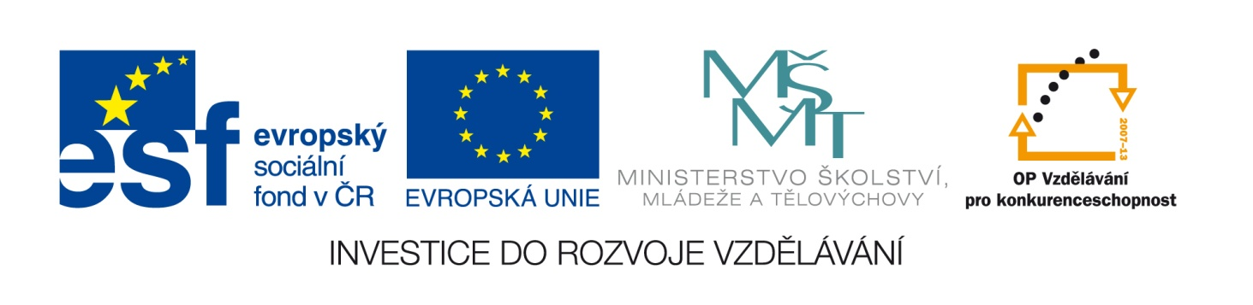Číslo šablony: III/2

VY_32_INOVACE_P1_3.2

**Tematická oblast: Exercises for Maturita Solutions  
 Pre-Intermediate**

**Conditional Clauses**

Typ: DUM – pracovní list

Předmět: Anglický jazyk

Ročník: 3. a 4. r. (6leté), 1. a 2. r. (4leté)

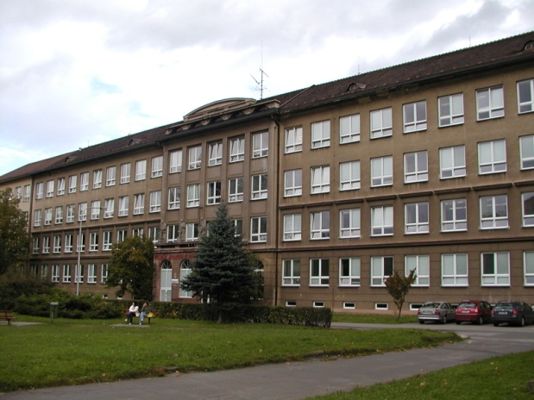

Zpracováno v rámci projektu

EU peníze školám

CZ.1.07/1.5.00/34.0296

Zpracovatel:

**Mgr. Lucie Samcová**

Gymnázium, Třinec, příspěvková organizace

**Datum vytvoření: leden 2014**

**Metodický list**

Pracovní list může být použit celý nebo jen jeho části.

Je určen k opakování, procvičení, shrnutí nebo prověřování gramatického učiva týkajícího se podmínkových vět nultého, prvního a druhého typu.

Cvičení 1., a 3. – student procvičuje podmínkové věty doplňováním sloves ve správném čase.

Cvičení 2., 4., 5. a 8. - student procvičuje danou gramatiku přepisováním nebo tvořením vět z daných slov nebo frází.

Cvičení 6. – student reaguje na dané věty tím, že tvoří otázky, kladné a záporné odpovědi.

Cvičení 8. – student vyhledává a spojuje věty do souvětí.

**DUM obsahuje klíč se správným řešením nebo příklady řešení.**

**CONDITIONAL CLAUSES**

**ZERO CONDITIONAL**

**1) Fill in.**

1. If you ______ (heat) water to 100 °C, it ______ (boil).
2. If the car ______ (run) out of petrol, it ______ (stop).
3. If Peter ______ (cut) his finger, he ______ (bleed).
4. If it______ (be) dark here, you ______ (have) to switch on the light.
5. If you ______ (not have) money, you ______ (go) to the cash machine.
6. If you ______ (drop) a pen, it ______ (fall).
7. If she ______ (can) help, she ______ (help).
8. If it ______ (not work), you ______ (must) repear it.

**FIRST CONDITIONAL**

**2) Make sentences.**

1. to lend him my phone (I) – to ask me nicely (he)
2. to book the hotel (I) – to give me the number and details (she)
3. to invite him tonight (we) – to meet him (we)
4. not to go to the theatre (they) – not to see the performance (they)
5. to pass the exam (you) – to study hard (you)
6. not to talk to her (I) – not to apologize (she)
7. to drink too much alcohol (you) – not to feel well (you)
8. to enjoy himself at the moment (he) – not to be mistaken (I)

**3) Complete the story.**

We have an exam next week. I have to study hard.

1. If I study hard, I____________ (get) good marks.
2. If I____________, my father ____________ (be) happy.
3. If my father ____________, he ____________ (buy) me a new bicycle.
4. If he ____________, I ____________ (start) riding more.
5. If I ____________, I ____________ (not have) time to study.
6. If I ____________, I ____________ (not get) good marks.
7. If I ____________, my parents ____________ (not be) happy with me.

**4) React and rewrite the sentences starting both IF and the main clause.**

**Mind the punctuation and negative.**

1. She should weigh the parcel or she'll pay extra money.

*a) If she doesn’t weigh the parcel, she will pay extra money.*

*b) She will pay extra money if she doesn’t weigh the parcel.*

1. They should reduce the price or no one will buy the house.
2. You should hurry up or they won't wait for you.
3. He should work harder or he will never learn the language.
4. She should hide the presents or the children will find them.
5. We should stop shopping or we won't have any money left.
6. I should remember his number or we won't stay in tough.

**SECOND CONDITIONAL**

**5) Make sentences with the words.**

1. be / If / you / in my place / you / understand /my troubles.
2. if / know / it / he / He / can / to us / explain / it.
3. if / go / they / with us / They / the performance / see.
4. If / can / I / it / do / I / it / do.
5. If / come / he / to the party / we / can /together / dance.
6. if / he / me / ask / I / marry / him.
7. if / finish / The students / reading the article / they /know / the answer.

**6) Make questions and answer them. Use conjunctions IF and NOT EVEN IF.**

1. You can marry him if he asks you to. *Q: Would you marry him if he asked you to? + Yes, I would marry him if he asked me to.*

*- No, I wouldn't marry him not even if he asked me to.*

1. You can make a phone call if it is urgent.
2. You can apologize if he asks you to.
3. You can give a party if you live alone.
4. We can go on holiday if I win in a lottery.
5. He can earn more money if he works harder.
6. I can study more if I stay up longer.

**7) Match the beginnings and endings of these sentences.**

1. The party wouldn't be such a fun a) if he knew what I know.
2. If they listened more carefully, b) if you were invited?
3. Would you come c) I would go to Barcelona for sightseeing.
4. If the roads were less busy, d) if he cared about other people's feelings.
5. He wouldn't be so happy e) if John weren’t here.
6. If I could speak Spanish, f) they wouldn't make so many mistakes.
7. He would behave himself g) I would start driving to work.

**8) Finish the story.**

If I heard a strange noise in our house, I would go after the noise.

If I went after the noise, ... to find a robber to run back to my room

to hide under my bed to call the police to catch the robber

to go and ask who he was to recognize my husband

**ANSWERS - CONDITIONAL CLAUSES**

**ZERO CONDITIONAL**

**1) Fill in.**

1. heat / boils
2. runs / stops
3. cuts / bleeds
4. is / have
5. don't have / go
6. drop / falls
7. can / helps
8. doesn't work / must

**FIRST CONDITIONAL**

**2) Make sentences.**

1. I'll lend him my phone if he asks me nicely.
2. I'll book the hotel if she gives me the number and details.
3. We'll invite him tonight if we meet him.
4. If they don't go to the theatre, they won't see the performance.
5. You will pass the exam if you study hard.
6. I won't talk to her if she doesn't apologize.
7. If you drink too much alcohol, you won't feel well.
8. He is enjoying himself at the moment if I'm not mistaken.

**3) Complete the story.**

We have an exam next week. I have to study hard.

1. study / will get
2. get / will be
3. is /will buy
4. buys / will start
5. start / won't have
6. don't have / won't get
7. don't get / won't be

**4) React and rewrite the sentences starting both IF and the main clause.**

**Mind the punctuation and negative.**

1. If she doesn't weigh the parcel, she'll pay extra money.

She will pay extra money if she doesn't weigh the parcel.

1. If they don't reduce the price, no one will buy the house.

No one will buy the house if they don't reduce the price.

1. If you don't hurry up, they won't wait for you.

They won't wait for you if you don't hurry up.

1. If he doesn't work harder, he will never learn the language.

He will never learn the language if he doesn't work harder.

1. If she doesn't hide the presents, the children will find them.

The children will find the presents if she doesn't hide them.

1. If we don't stop shopping, we won't have any money left.

We won't have any money left if we don't stop shopping.

1. If I don't remember his number, we won't stay in tough.

We won't stay in tough if I don't remember his number.

**SECOND CONDITIONAL**

**5) Make sentences with the words.**

1. If you were in my place, you would understand my troubles.
2. He could explain it to us if he knew it.
3. They would see the performance if they went with us.
4. If I could do it, I would do it.
5. If he came to the party, we could dance together.
6. I would marry him if he asked me.
7. The students would know the answer if they finished reading the article.

**6) Make questions and answer them. Use conjunctions IF and NOT EVEN IF.**

1. You can marry him if he asks you to. Q: *Would you marry him if he asked you to?*

*+ Yes, I would marry him if he asked me to.*

*- No, I wouldn't marry him not even if he asked me to.*

1. Q: Would you make the phone call if it were urgent?

**+**  Yes, I would make … **-** No, I wouldn't make …

1. Q: Would you apologize if he asked you to?

**+** Yes, I would apologize … **-**  No, I wouldn't apologize …

1. Q: Would you give a party if you lived alone?

+ Yes, I would give … - No, I wouldn't give …

1. Q: Would we go on holiday if I won in a lottery?

+ Yes, we would go … - No, we wouldn’t go ...

1. Q: Would he earn more money if he worked harder?

+ Yes, he would earn … - No, he wouldn't earn …

1. Q: Would I study more if I stayed up longer?

+ Yes, I would study … - No, I wouldn't study …

**7) Match the beginnings and endings of these sentences.**

1e 2f 3b 4g 5a 6c 7d

**8) Finish the story.**

If I heard a strange noise in our house, I would go after the noise.

If I went after the noise, I would find a robber.

If I found a robber, I would run back to my room.

If I ran back to my room, I would hide under my bed.

If I hid under my bed, I would call the police.

If I called the police, they would catch the robber.

If they caught the robber, I would go and ask who he was.

If I went and asked who he was, I would recognize my husband.

**POUŽITÁ LITERATURA**:

FALLA, Tim, DAVIES, Paul, A. *Maturita Solutions Pre-Intermediate Student’s Book*. Oxford University Press. 2007. ISBN 978-0-19-455168-7.

FALLA, Tim, DAVIES, Paul, A. *Maturita Solutions Pre-Intermediate Workbook*. Oxford University Press. 2007. ISBN 978-0-19-455171-7.

*ZÁBOJOVÁ, Eva, PEPRNÍK, Jaroslav, NANGONOVÁ, Stella. Angličtina pro jazykové školy II.* Fortuna, 1997.ISBN 80-7168-492-9.

*HASHEMI, Louise, THOMAS, Barbara. Grammar for First Certificate. Second edition.* Cambridge University Press, 2008. ISBN 978-0-521-69087-4.

SWAN, Michael, WALTER, Catherine. *The Good Grammar Book.* Oxford University Press. 2001. ISBN 0-19-431519-3.

NAYLOR, Helen, MURPHY, Raymond. *Essentian Grammar in Use Supplementary Exercises. Second edition.* Cambridge University Press. 2007. ISBN 978-0-521-67542-0.

MURPHY, Raymond. *English Grammar in Use with answers. Second edition*. Cambridge University Press, 1994. ISBN 0-521-43680-X.

Vlastní archiv autora