Číslo šablony: III/2

VY_32_INOVACE_P1_3.17

**Tematická oblast: Exercises for Maturita Solutions Pre-Intermediate**

**Shopping**

Typ: DUM – pracovní list

Předmět: Anglický jazyk

Ročník: 3. r. (6leté), 1. r. (4leté)

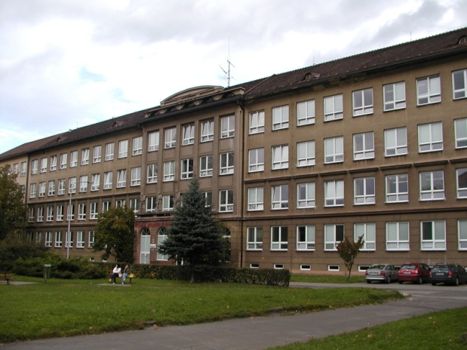

Zpracováno v rámci projektu

EU peníze školám

CZ.1.07/1.5.00/34.0296

Zpracovatel:

**Bc. Barbora Zawiszová**

Gymnázium, Třinec, příspěvková organizace

Datum vytvoření: **květen 2014**

**Metodický list**

Pracovní list může být použit celý nebo jen jeho části.

Je určen k procvičení, opakování, shrnutí nebo prověřování slovní zásoby týkající se nakupování.

Žáci jsou vedeni k samostatnému písemnému nebo ústnímu projevu na základě cvičení  
a obrazových podnětů.

Řešení k obrázkům uvádí pouze slovní zásobu, správnost vět posoudí vyučující.

MC900435945[1]***Match the items with the correct shop.***

1. bread, butter, ham, eggs, wafers

2. cakes, lollipops, ice cream, sundae

3. cod, salmon, seafood, trout

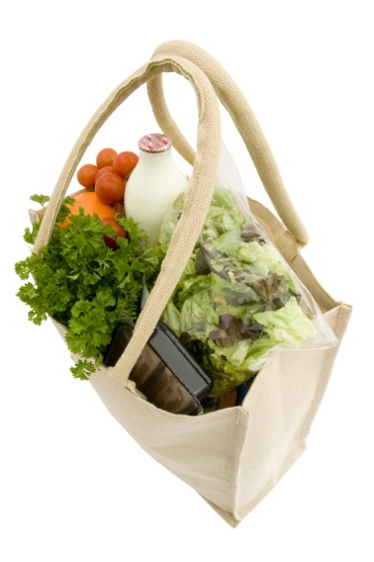4. flowers, plants, flowerpots, small presents

5. cauliflower, lettuce, parsley, celery

6. perfume, shampoo, soap, cream

7. screws, nails, hammers, power saws

8. beer, wine, vodka, alcoholic beverages

9. pipes, tobacco, cigarettes, cigars

10. newspapers, magazines, postcards, stamps

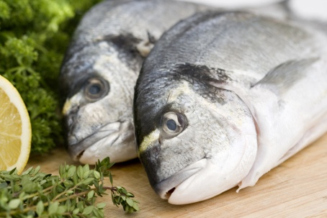

**A. the confectioner´s**

MC900442030[1]**B. the chemists´s**

**C. the florist´s**

**D. the off-licence**

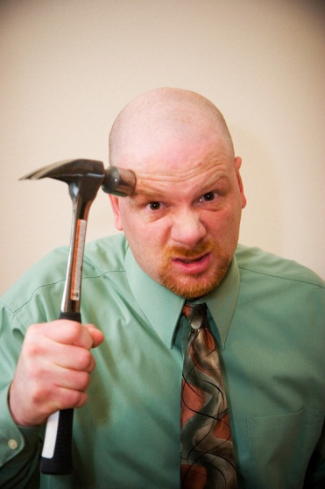**E. the grocer´s**

**F. the fishmonger´s**

**G. the ironmonger´s**

**H. the tobacconist´s**

**I. the greengrocer´s**

**J. the newsagent´s**

**Insert the correct word. Complete the phrases with *cost* or *price.***

1. MC900312546[1]MC900312546[1]Is it expensive to live in Třinec? Yes, actually the ......... of living is quite high.
2. 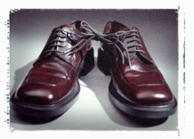Why have you bought two of shampoo? Well, it was a special offer, I got these two for the ........ of one.
3. These are nice ... Were they expensive? No, I bought them half ........ in the sales.
4. 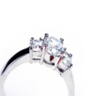May I see the ........ list for this cosmetics catalogue? Sure, here you are.
5. How much does this ..........? I don´t know what the ......... is. You have to ask the shop assistant.
6. Did you pay much for the concert? Well, the ......... of the ticket was only 100 CZK, but the journey and accommodation were rather expensive. The total ......... was over 1,000 CZK. It ......... me an arm and a leg to see that performance.
7. I like your new . Was it expensive? It didn´t ........ me a penny, I got it from my father as a birthday present.
8. Mum, can I have this bag? Well, look at the and see how much it is.

MC900113370[1]MC900113450[1]MC900234417[1]MC900155643[1]

**1 2 3 4**

**MC900113404[1]**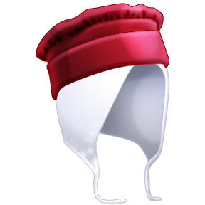MC900113476[1]

**MC900113304[1]**

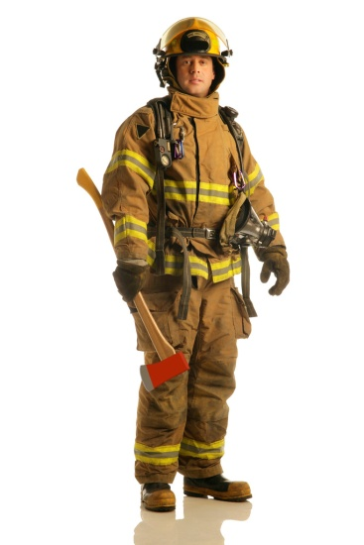**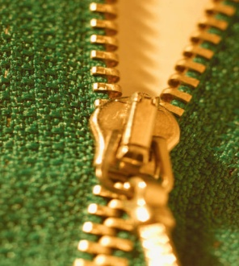5 6 7 8**

MC900412368[1]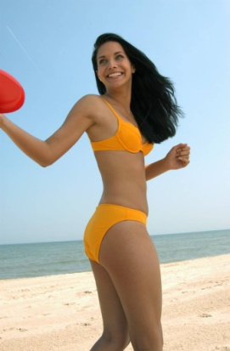

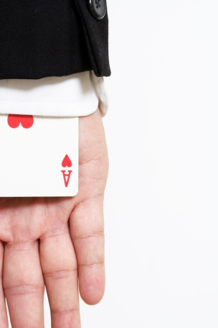**9 10 11 12**

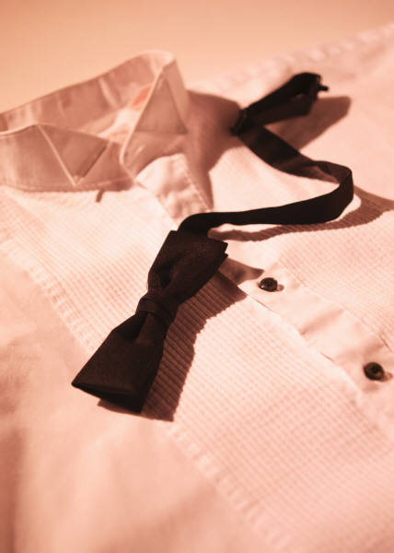

**13 14 15 16**

***Use these items or parts of clothing in a sentence.***

***Solution:***

**Page 1:**

1 E, 2 A, 3 F, 4 C, 5 I, 6 B, 7 G, 8 D, 9 H, 10 J

**Page 2:**

1. the cost of living

2. (bottles), two for the price of one

3. (new / nice shoes), half-price

4. price list

5. (diamond / beautiful / marvellous ring), what the price is.

6. the price of the ticket, total cost, It cost me an arm and a leg .

7. (bike / bicycle), It didn´t cost me a penny

8. price tag

**Page 3:**

1. high-heeled shoes
2. strapped dress
3. short-sleeved T-shirt
4. flared / bell-shaped skirt
5. trousers / jeans
6. anorak, hooded jacket, winter jacket
7. cap
8. leather belt, buckle
9. zip (fastener)
10. fireman uniform, safety helmet
11. swimsuit, bikini
12. hooded cloak
13. sleeve, cuff, cuff button
14. striped tie / tie with a stripe and dotted line pattern
15. bow tie / shirt with long sleeves / neatly ironed (out)
16. life jacket / vest

***Zdroje:***

Archiv autora

Obrázky – Microsoft Clipart