Číslo šablony: III/2

VY_32_INOVACE_P1_3.16

**Tematická oblast: Exercises for Maturita Solutions Pre-Intermediate**

**Modal Verbs**

Typ: DUM – pracovní list

Předmět: Anglický jazyk

Ročník: 3. a 4. r. (6leté), 1. a 2. r. (4leté)

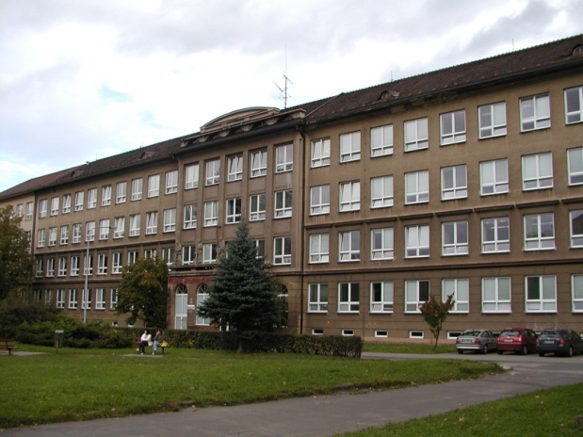

Zpracováno v rámci projektu

EU peníze školám

CZ.1.07/1.5.00/34.0296

Zpracovatel: **Mgr. Lenka Rašková**

Gymnázium, Třinec, příspěvková organizace

Datum vytvoření: **březen 2014**

**Metodický list**

Pracovní list může být použit celý nebo jen jeho části. S pracovním listem je možno pracovat jak formou samostatné práce žáků, tak formou práce skupinové.

Cílem DUMu je procvičit používání všech modálních sloves. První úkol procvičuje použití modálních sloves v běžných komunikačních situacích podle obrázků. Druhou částí pracovního listu je kreativní vytváření dedukcí a různé míry pravděpodobnosti   
za použití modálních sloves, která mají popsat život neznámého člověka. Cvičení lze zadat i jako domácí nebo soutěžní úkol. V poslední části PL si žáci mohou procvičit použití SHOULD nebo OUGHT TO ve větách kladných a záporných pro přítomné  
i minulé děje, které jsou součástí příběhu.

DUM obsahuje klíč se správným řešením nebo příklady řešení.

Inovace spočívá ve využití interaktivního prostředí.

**1/ Look at the situations in the pictures below. Use apppropriate modal verbs to complete**

**the sentences below the pictures. Sometimes there are more possibilities for each sentence.**

**MC900409835[1]**MC900360720[1]

MC900196444[1]A/ She / get up early / on Sundays.

MC900360724[1] E/ have / a pizza, please?

B/ Take an umbrella. It / rain.

j0297551MC900405982[1] F/ You / use suntan lotion not to

get sunburnt.

MC900229135[1]

MC900212141[1]C/ Kids, you /play with matches! G/ Keira / ski very well.

MC900355297[1]

D/ Flight attendants / wear uniforms. H/ borrow / the book, please?

MC900088954[1]MC900088940[1]

I/ Peter looks tired. He / have a lot of homework. M/ It´s a secret. You / not tell

MC900438129[1] anybody!

MC900410243[1]

J/ Kate is eating but Emma isn´t. Emma / be sick.

(Emma / not be hungry)

MC900411496[1] N/ You´re too lonely. You /

find some friends.

MC900440623[1]

K/ My aunt has got a headache very often.

She / go to the doctor.

MC900318584[1]MC900428133[1]

O/ Hello, / I / talk to Mr. Smith?

L/ you / help me with the bags?

In hospital there is a seriously wounded man, lying in a coma. No documents have been found in his bag. He is all over wrapped in bandages. Nobody has come to identify him. In his bag a few objecst have been found. Have a look at the objects in the pictures below and make deduction about his identity and life using modal verbs.

e.g. The man might be a tennis player. He may play tennis regularly.

MC900436015[1]

?



MC900030588[1]

MC900059645[1]

MC900282472[1]

MC900398055[1]

MC900238363[1]

MC900339256[1]



MC900371338[1]MC900358371[1]

dglxasset[2]

HARDWORK´S STORY

Mr. Gary Hardwork works for an international trading company. He works about 12 hours a day. He only gets home from the office at 9 p.m. He is a heavy smoker. His diet is not healthy. He prefers junk food. Mr.Hardwork doesn´t spend much time with his wife and two kids. Last weekend his son was seven years old but Mr.Hardwork didn´t celebrate the birthday with his son. He was at work. At the moment he´s driving home from work. He´s tired and is doing 160 km per hour on the motorway. He´s got one hand on the steering wheel and with the other he is making a phone call to his client.

**3/ Complete the sentences about Mr Hardwork and his life using appropriate modals**

**SHOULD/OUGHT TO in both affirmative and negative sentences about the present**

**and past situations.**

A/ He ___________________ work so hard.

B/ He ___________________come home earlier.

C/ He ___________________smoke so much.

D/ He ___________________eat so much junk food.

E/ He ___________________spend more time with his family.

F/ He ____________________his son´s birthday last weekend.

G/ He ___________________ so fast now.

H/ He __________________ both hands on the steering wheel.

I/ He ___________________a phone call when he´s driving.

**4/ Imagine your classmate has got some problems as suggested in the sentences below. Give**

**him or her a piece of advice using SHOULD in affirmative or negative sentences.**

A/ Oh, not again. I´ve failed another exam! For the third time this week.

B/ Someone´s stolen my bike.

C/ I´ve had a big argument with my girlfriend. Now I think she was right.

D/ I want to go to the party on Friday but my parents won´t let me go there.**Klíč**

**1/  
A/ She needn´t get up early on Sundays.**

**B/ Take an umbrella. It may/ might/ could rain.**

**C/ Kids, you mustn´t play with the matches!**

**D/ Flight attendants have to wear uniforms.**

**E/ Can/ could I have a pizza please?**

**F/ You must / should use suntan lotion not to get sunburnt.**

**G/ Keira can ski very well.**

**H/ May/ can / could I borrow the book please?**

**I/ Peter looks tired. He must have a lot of homework.**

**J/ Kate is eating but Emma isn´t. Emma must be sick. Emma can´t be hungry.**

**K/ My aunt has a headache very often. She should go to the doctor.**

**L/ Can / could you help me with the bags?**

**M/ It´s a secret. You mustn´t tell anybody.**

**N/ You´re too lonely. You should / must find some friends.**

**O/ Hello, may/ can / could I speak to Mr. Smith?**

**2/ Students´own aswers**

**3/  
A/ He shouldn´t work so hard.**

**B/ He should come home earlier.**

**C/ He shouldn´t smoke so much.**

**D/ He shouldn´t eat so much junk food.**

**E/ He should spend more time with his family.**

**F/ He should have celebrated his son´s birthday last weekend.**

**G/ He shouldn´t be driving so fast now.**

**H/ He should have both hands on the steering wheel.**

**I/ He shouldn´t be making a phone call when he´s driving.**

**4/ Suggested answers:**

**A/ You should study harder. You shouldn´t be so lazy.**

**B/ You should go to the police.**

**C/ You should apologise.**

**D/ You should promise to be back soon.**

**Zdroje:**

1/EVANS, Virginia. *Round-up*. New and updated ed. Harlow: Longman, 2003. ISBN 05-828-2343-9.

2/ ZAOROB, Maria Lucia a Elizabeth CHIN. *Games for grammar practice: a resource book of grammar games and interactive activities*. 1st publ. Cambridge: Cambridge University Press, 2001, 114 s. ISBN 978-0-521-66342-72007.

3/ GOODEY, By David Bolton. *Grammar practice in context: english grammar practice exercises covering the 100 most important grammar topics and structures*. 1st ed. London: Richmond, 1997. ISBN 84-294-5065-3.

**Obrázky:**

galerie Microsoft Word