Číslo šablony: III/2

VY_32_INOVACE_P1_3.13

**Tematická oblast: Exercises for Maturita Solutions Pre-Intermediate**

**Comparatives and Superlatives**

Typ: DUM - pracovní list

Předmět: Anglický jazyk

Ročník: 3. r. (6leté), 1. r. (4leté)

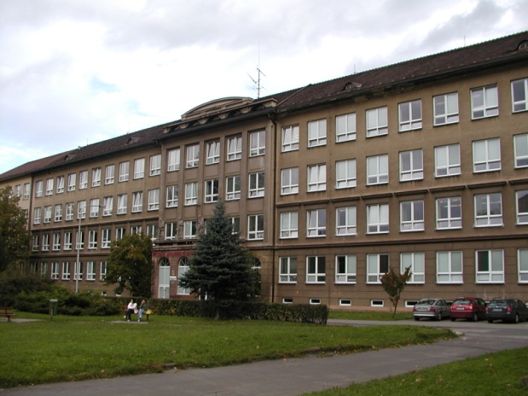

Zpracováno v rámci projektu

EU peníze školám

CZ.1.07/1.5.00/34.0296

Zpracovatel:

**Bc. Barbora Zawiszová**

Gymnázium, Třinec, příspěvková organizace

Datum vytvoření: **duben 2014**

**Metodický list**

DUM může být použit celý nebo jen jeho části, je určen pro procvičení, opakování, shrnutí nebo prověření gramatického učiva.

Cílem je systematizovat gramatické učivo a zlepšit výsledky žáků. Interaktivní prostředí umožňuje lepší praktické využití PL a větší přehlednost procvičovaného učiva.

Žáci plní úkoly podle pokynů, řešení je uvedeno v závěru.

***1. Write the missing forms of the adjectives.***

|  |  |  |
| --- | --- | --- |
|  |  | **the smallest** |
| **generous** |  |  |
|  | **worse** |  |
|  |  | **the best** |
| **scary** |  |  |
|  | **busier** |  |
|  |  | **the fewest** |
| **little** |  |  |
|  | **hotter** |  |
|  |  | **the heaviest** |
| **slim** |  |  |
|  | **further** |  |
|  |  | **the most gripping** |

***2. Write the opposite.***

**older ................................ the cheapest ..................................**

**easier ............................... the heaviest ...................................**

**nearer .............................. the fastest ......................................**

**more people..................... the best ..........................................**

**more beautiful ................. the nearest .....................................**

**smaller ............................. the most polite ...............................**

**later ................................. the prettiest ...................................**

***3. Write the sentences using the prompts.***

**MC900434403[1]**

***A) John is 168 cm tall. Patrick is 170 cm tall.***

John is /short / a bit / than / Patrick.

Patrick is not /than / tall / much / John.

John is / as / almost / as / tall / Patrick.

John is not / much / than / short / Patrick.

***B) My brother is 6. Your brother is 16.***

My brother is / young / much / than / your brother.

My brother isn’t /old / so / as / your brother.

Your brother is / than / my brother / old / much.

Your brother isn’t / young / as / as / my brother / at all.

*MC900398513[1]MC900398511[1]****C) Car A - 200,000CZK Car B – 220,000CZK Car C – 380,000CZK***

MC900398461[1]

Car A is / not much / cheap / Car B / than.

Car C is / far / expensive / than / Car A.

Car A is / cheap / of all.

Car B is / expensive / slightly / than (2x) / but / Car A / Car C / much / cheap.

***4. Choose the correct option.***

**1. I got up ... yesterday.**

a) a little later b) more later c) a more late

**2. The grammar gets harder and ... .**

a) more hard b) the hardest c) harder

**3. The sooner we leave, ... we‘ll get there.**

a) sooner b) the sooner c) a sooner

**4. The car was going ... and faster down the hill.**

a) the faster b) faster c)more faster

**5. His performance is ... good.**

a) slightly less b) as much c) more

**6. Are chimpanzees ... intelligent animals in the world?**

a) a more b) the more c) the most

**7. Is football ... popular as ice hockey?**

a) more b) so c) as

**8. Do you think math is ... difficult than English?**

a) so b) more c) as

**9. This is too small. Have you got anything ... ?**

a) more big b) bigger c)less smaller

**10. It was ... moving film I’ve ever seen.**

a) the best b) the more c) the most

***5. Fill in the missing words. (Sometimes more than one option is possible.)***

1. What is ... biggest country in the world?
2. Is the River Nile ... or shorter than the Mississippi River?
3. Are you older ... I am?
4. Who is the ... amusing person of your class?
5. **MC900438012[1]**I was ... scared ... you when we watched the film.
6. Is this new story ... funny ... that old one?
7. Henry was ... least confused of all.
8. It is ... faster than you can imagine.
9. Everything is getting more and ... expensive.
10. I will need a ... more water.
11. We play computer games ... and go out ... often than before.
12. I feel ... better today.
13. I am not so tired ... I was yesterday.
14. It is the same ... the one I showed you.
15. This is ... nicest colour.

ŘEŠENÍ

1)

small / smaller / the smallest

generous / more generous / the most generous

bad/ ill / worse / the worst

good / better / the best

scary / scarier / the scariest

busy / busier / the busiest

few / fewer / the fewest

little / less / the least

hot / hotter / the hottest

heavy / heavier / the heaviest

slim / slimmer / the slimmest

far / further / the furthest

gripping / more gripping / the most gripping

2)

younger, more difficult, farther/further, fewer people, less beautiful/uglier, bigger, earlier, the most expensive, the lightest/the most lightweight, the worst, the farthest/furthest, the meanest/the rudest/the most impolite, the ugliest/the least pretty

3)

John is a bit shorter than Patrick.

Patrick is not much taller than John.

John is almost as tall as Patrick.

John is not much shorter than Patrick.

My brother is much younger than your brother.

My brother isn’t so/as old as your brother.

Your brother is much older than my brother.

Your brother isn’t as young as my brother at all.

Car A is not much cheaper than car B.

Car C is far more expensive than car A.

Car A is the cheapest of all.

Car B is slightly more expensive than car A but much cheaper than car C.

4)

1 – a

2 – c

3 – b

4 – b

5 – a

6 – c

7 – c

8 – b

9 – b

10 – c

5)

1. the
2. longer
3. than
4. most
5. more/less, than
6. as … as
7. the
8. much
9. more
10. lot / bit
11. more … less / less … more
12. much
13. as
14. as
15. the

**Zdroje - texty:**

Archiv autora

Klipart Microsoft Word