Číslo šablony: III/2

VY_32_INOVACE_P1_3.12

**Tematická oblast: Exercises for Maturita Solutions Pre-Intermediate**

**Arts**

Typ: DUM - pracovní list

Předmět: Anglický jazyk

Ročník: 3. r. (6leté), 1. r. (4leté)

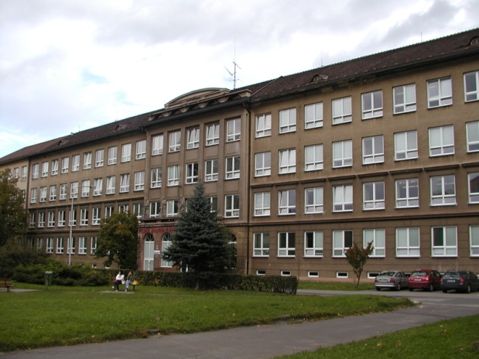

Zpracováno v rámci projektu

EU peníze školám

CZ.1.07/1.5.00/34.0296

Zpracovatel:

**Bc. Barbora Zawiszová**

Gymnázium, Třinec, příspěvková organizace

Datum vytvoření: **duben 2014**

**Metodický list**

DUM může být použit celý nebo jen jeho části, je určen pro procvičení, opakování, shrnutí nebo prověření gramatického učiva.

Cílem je systematizovat gramatické učivo a zlepšit výsledky žáků. Interaktivní prostředí umožňuje lepší praktické využití PL a větší přehlednost procvičovaného učiva.

Žáci plní úkoly podle pokynů, řešení je uvedeno v závěru.

***A) Match the words with their definitions.***

1. **A famous /very well known actor or actress.**
2. **The people who watch the play at the theatre.**
3. **A film that makes people laugh.**
4. **The piece of writing which the critic writes about a film, book or play.**
5. **To reserve tickets before the performance.**
6. **The person who says what the actors are to do.**
7. **A small part of a film.**
8. **The person who writes articles about films and plays.**
9. **The total number of actors in a film or play.**
10. **The person who writes books or essays about famous people.**
11. **A film about America in the 19th century; often with cowboys and indians.**
12. **The activity which the people do with their hands after the end of a play at the theatre.**
13. **A very gripping story often about a crime.**
14. **Parts of films which are shown to advertise and promote new films.**
15. **If you do not understand what the actors say, you need to read them.**
16. **BIOGRAPHER**
17. **STAR**
18. **REVIEW**
19. **THRILLER**
20. **DIRECTOR**
21. **TRAILERS**
22. **SCENE**
23. **CRITIC**
24. **WESTERN**
25. **SUBTITLES**
26. **CAST**
27. **BOOK**
28. **COMEDY**
29. **AUDIENCE**
30. **CLAP**

***B) Look at the pictures and fill in the chart.***

**Note that there are more possible solutions.**

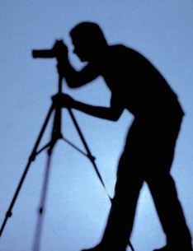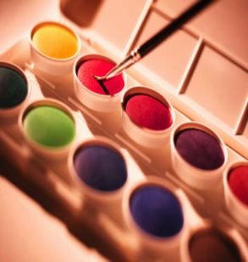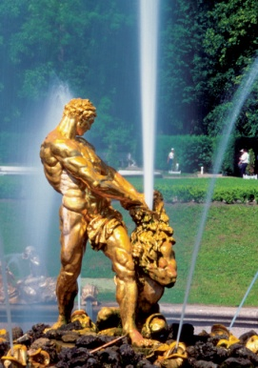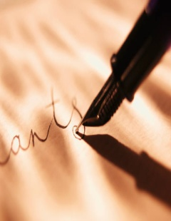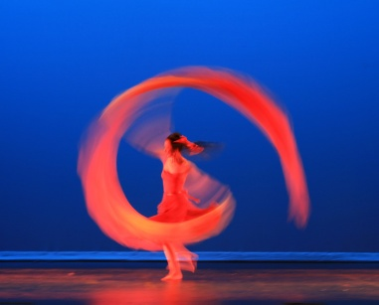

**1 2 3 4 5 6**

|  |  |  |  |
| --- | --- | --- | --- |
| **1** | **PHOTOGRAPHER** | **TAKE PICTURES** | **CAMERA, PHOTO** |
| **2** |  |  |  |
| **3** |  |  |  |
| **4** |  |  |  |
| **5** |  |  |  |
| **6** |  |  |  |

MC900240661[1]

***C) What are the people doing?***

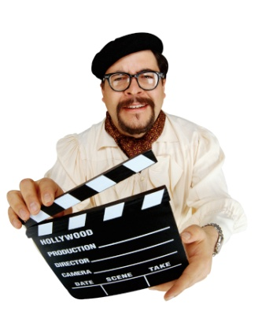

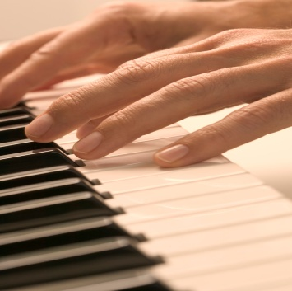MC900343329[1]

3 4

**1 2**

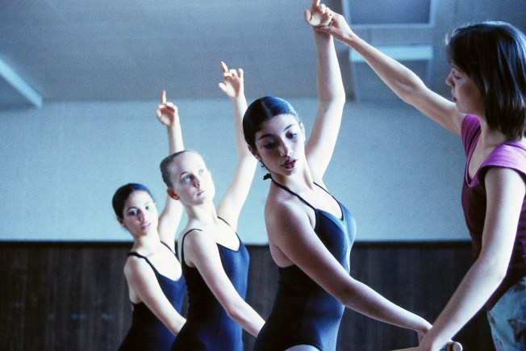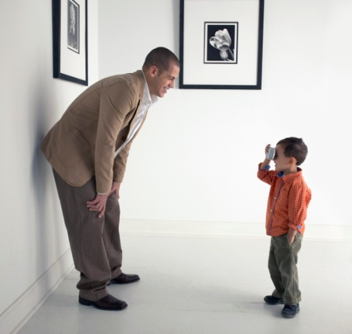**5 6 7**

MC900278966[1]***D) Use the words to complete the sentences.***

1. **POEMS**
2. **GALLERY**
3. **STILL LIFE**
4. **ARTIST**
5. **SOUNDTRACK**
6. **PAINTINGS**
7. **POETRY**
8. **EXIBITION**
9. **COSTUMES**
10. **RECITE**

**My sister is an ...........1........... . Her .........2........... are quite unusual but I like them.**

**Last week an art .........3............ contacted her because they wanted to put on an.........4........ of her work.**

**When we did ..........5.......... at school, we had to learn whole ..........6.......... by heart and then ..........7........... them for the whole class.**

**Many ..........8........... paintings contain a bowl of fruit and a bottle.**

**Have you heard the ...........9 ........... for the film Once? It’s great.**

**The actors were wearing historical .........10......... which I liked very much.**

***E) Choose the correct option.***

At the theatre you can see plays / games, e.g. Romeo and Juliet by Shakespeare. They are watched / performed on stage / scene. Films are usually played / shown on screen / cinema. Foreign films might be dubbed / dubbing or they have subscription / subtitles.

MC900370548[1]If you want to see paintings / painters of a famous artists / artist, you can go to an art gallery / paint gallery. There you can see individual paintings or collection / group of paintings by one artist. You can see pictures / portraits (a painting of a person) or landscapes / scenery (a painting of part of the countryside).

This film was mainly filmed on location / on site in the Czech Republic.

Solution

A)

1 – B

2 – N

3 – M

4 – C

5 – L

6 – E

7 – G

8 – H

9 – K

10 – A

11 – I

12 – O

13 – D

14 – F

15 – J

B)

Photographer / take pictures / camera, photos, pictures, snaps

Painter, artist / paint / painting, picture, brush, colours

Artist, draughtsman, cartoonist / draw, sketch / picture, coloured pencils, crayons

Sculptor / sculpt (vyřezat, vytesat), create, make / sculpture, statue

Writer / write, create, publish / novel, story, essay

Dancer / dance, perform, rehears / dance, dancing, ballet, performance, ribbon (stuha)

C)

Žáci tvoří věty dle svých schopností – kontrola učitele.

D)

1 – D

2 – F

3 – B

4 – H

5 – G

6 – A

7 – J

8 – C

9 – E

10 – I

E)

At the theatre you can see plays , e.g. Romeo and Juliet by Shakespeare. They are performed on stage. Films are usually shown on screen . Foreign films might be dubbed or they have subtitles.

MC900370548[1]If you want to see paintings of a famous artist, you can go to an art gallery. There you can see individual paintings or collection of paintings by one artist. You can see portraits   
 (a painting of a person) or landscapes (a painting of part of the countryside).

This film was mainly filmed on location in the Czech Republic.

**Zdroje**

Archiv autora

Klipart Microsoft Word

GOUGH, Chris. *English vocabulary organiser: 100 topics for self-study*. 3. print. Boston, MA: Thomson, 2004. ISBN 978-189-9396-368.

REDMAN, Stuart. *English Vocabulary in Use pre-Intermediate and Intermediate*. 1st ed. Hong Kong: Cambridge Univ. Press, 1997, 270 s. ISBN 05-215-5737-2.