Číslo šablony: III/2

VY_32_INOVACE_P1_3.11

**Tematická oblast: Exercises for Maturita Solutions Pre-Intermediate**

**SPORT**

Typ: DUM – pracovní list

Předmět: Anglický jazyk

Ročník: 3. a 6. r. (6leté), 1. a 4. r. (4leté)

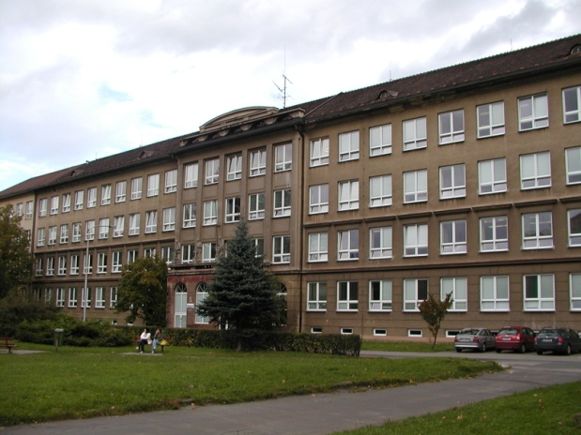

Zpracováno v rámci projektu

EU peníze školám

CZ.1.07/1.5.00/34.0296

Zpracovatel:

**Mgr. Vilma Sikorová**

Gymnázium, Třinec, příspěvková organizace

Datum vytvoření: **únor 2014**

**Metodický list**

Pracovní list je určen k procvičování a upevňování slovní zásoby na téma Sport.   
Lze s ním pracovat jak formou samostatné práce žáků, tak formou práce ve dvojicích  
a ve skupinách.  
 **Cvičení v části A** (1 – 3)upevňují slovní zásobu pro míčové hry,  **část B** (cvičení 4 – 6) se věnuje procvičování slovní zásoby pro jiné sporty.   
  
**Cvičení 7** je určeno pro práci ve dvojicích, ale lze jej využít jako podklad pro diskusi ve skupinách nebo v celé třídě.

I když byl DUM vytvořen jako pracovní list k učebnici **Maturita Solutions  
Pre-Intermediate,** lze jej využít i v jiných skupinách žáků jako podklad pro rozvíjení řečových dovedností na dané téma a jeho opakování.  
   
  
Součástí DUMu je správné řešení pro jednotlivá cvičení s výjimkou cvičení 7, které vyžaduje vlastní odpovědi žáků.

[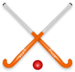](http://www.clker.com/clipart-hockey-stick-ball.html)  
**A) BALL AND RACQUET SPORTS  
1a) There are some pieces of equipment needed while doing a sport.   
 Match the sports with the pictures.** *basketball bowling rugby  
 hockey volleyball tennis  
 golf badminton baseball  
 football table tennis ice hockey*

[](http://www.clker.com/clipart-4562.html)[Ball Football Clip Art](http://www.clker.com/clipart-15136.html) **3.**  **2.**

1. [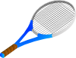](http://www.clker.com/clipart-4550.html)[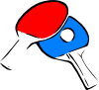](http://www.clker.com/clipart-4564.html)

[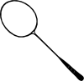](http://www.clker.com/clipart-4576.html)[Golf Club Clip Art](http://www.clker.com/clipart-golf-club.html)  **6.**

**4.** [](http://www.clker.com/clipart-bowling-pins-1.html)

**[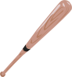](http://www.clker.com/clipart-4555.html)**  **5.**  **7.**

[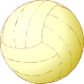](http://www.clker.com/clipart-4566.html)[](http://www.clker.com/clipart-10940.html)[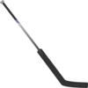](http://www.clker.com/clipart-hockey-stick.html) **8.**

**12.**

**9. 10. 11.**

**[](http://www.clker.com/clipart-25627.html)[Court Clip Art](http://www.clker.com/clipart-29057.html)[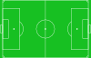](http://www.clker.com/clipart-4578.html)1b) What games are played on a**  *a. court*  
  *b. pitch*  
 *c. course?*   
  
 **1c)** **Try to give the name of the playing area for:** *bowling, ice hockey,*   
 *baseball, table tennis.*

**2) What can be done with the ball?  
 Complete the words with the missing letters.  
  
 h** _ _ it **t**_ _ _ _ it **p**_ _ _ it  
  **k**_ _ _ it **c**_ _ _ _ it **h**_ _ _ it

**3) What are the listed games played with?  
 Choose the correct word from the box.** *bat racket club stick*

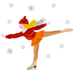[Rollerblading Beginner Clip Art](http://www.clker.com/clipart-2407.html)  **1** table tennis **2** badminton **3** golf **4** ice hockey   
 **5** baseball **6** tennis **7** squash   
  
  
**B) OTHER SPORTS**   
**4) Match the sports with the pictures.**   
  *swimming archery snowboarding   
 figure skating horse racing mountaineering  
 skiing gymnastics fencing  
 weightlifting orienteering in-line skating*

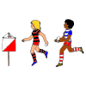[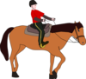](http://www.clker.com/clipart-horse-riding-lesson.html)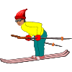[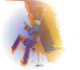](http://www.clker.com/clipart-16336.html)

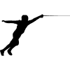[](http://www.clker.com/clipart-9445.html)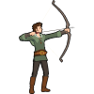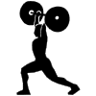  
**1. 2. 3. 4. 5. 6.**

[](http://www.clker.com/clipart-swimming-person-1.html)

**7. 8. 9. 10. 11. 12.**

**5) True or false? If false, correct the sentence to make it true.**

1. Boxers wear gloves. ________   
 2. Gymnastics is a game played in teams. ________  
 3. The people who watch a football match are the audience. ________  
 4. Women wear trunks for swimming. ________  
 5. The official who gives the score in tennis is the umpire. ________  
 6. Golf is an indoor sport. ________  
 7. Wrestling matches are held in a ring. ________   
 8. People go horse racing on a court. ________  
 9. Athlets wear running shoes or spikes. ________  
 10. The referee in football has a whistle. ________  
  
  
**6) Organise these words and put them in the correct columns below.** (You can put a word in more than one column.)  
  
  *bowling course track shorts costume poles golf  
 pool athletics pins crash helmet boots ball skates  
 swimming alley skiing slope club figure skating  
 trunks motor racing goggles spikes vest rink*

|  |  |  |
| --- | --- | --- |
| **Sport** | **Place** | **Equipment** |
|  |  |  |

**7) Work in pairs. Ask your friend some of these questions.**

1. What do you do to keep fit?  
 2. Do you enjoy watching sports events on TV? Why? Why not?  
 3. Do you agree that boys prefer team sports to individual ones?  
 4. Why do you think the extreme sports are so attractive today?  
 List some of them.  
 5. Which sports are popular in our country?   
 6. Do you support a team or an individual sportsman / sportswoman ?  
 7. What qualities make a champion?  
 8. Could you list any of athletics events?

**Řešení:**   
**1a)**1. rugby 5. golf 9. ice hockey  
2. hockey 6. tennis 10. basketball  
3. football 7. bowling 11. volleyball  
4. table tennis 8. badminton 12. baseball   
**1b)**  
**a. court:** tennis, badminton, basketball, volleyball  
**b. pitch:** rugby, hockey, football  
**c. course:** golf  
**1c) bowling:** alley; **ice hockey:** rink; **baseball:** baseball stadium/field; **table tennis:** table   
  
**2)  
h**it it  **t**hrow it **p**ass it  
**k**ick it  **c**atch it **h**ead it  
  
**3)  
racket:** badminton, tennis, squash (2, 6, 7)  
**bat:** table tennis, baseball (1, 5)  
**club:** golf (3)  
**stick:** ice hockey (4)  
  
**4)**1. mountaineering 5. figure skating 9. archery  
2. in-line skating 6. orienteering 10. gymnastics  
3. skiing 7. weightlifting 11. fencing  
4. horce racing 8. snowboarding 12. swimming   
  
**5)  
True sentences:** 1, 5, 7, 9, 10  
2. Gymnastics **is not a game.**  
3. The people who watch a football match are **the spectators.**   
4. Women wear **swimming costumes** for swimming. 6. Golf is an **outdoor** sport.   
8. People go horse racing on **a track.  
  
6)  
Sport Place Equipment**bowling alley ball, pins  
athletics track shorts, vest, spikes  
swimming pool costume, trunks, goggles  
skiing slope boots, poles, goggles  
figure skating rink skates  
golf course club, ball  
motor racing track crash helmet

**Zdroje:**

* REDMAN, Stuart. *English Vocabulary in Use pre-Intermediate and Intermediate*. 1st ed. Hong Kong: Cambridge Univ. Press, 1997, 270 s. ISBN 0 521 55737 2.
* GOUGH, Chris. *English vocabulary organiser: 100 topics for self-study*. Hove: Language Teaching Publications, c2001, 224 s. ISBN 18-993-9636-5.
* Archiv autora
* **Obrázky:**

Galerie Microsoft Word  
http://www.clker.com  
http://www.openclipart.org