Číslo šablony: III/2

VY_32_INOVACE_P1_2.15  
**Tematická oblast: Festivals and Celebrations**

REVISION – HOLIDAYS IN THE UK AND THE USA

typ: DUM - test

Předmět: AJ

Ročník: 4. r. (6leté), 2. r. (4leté)

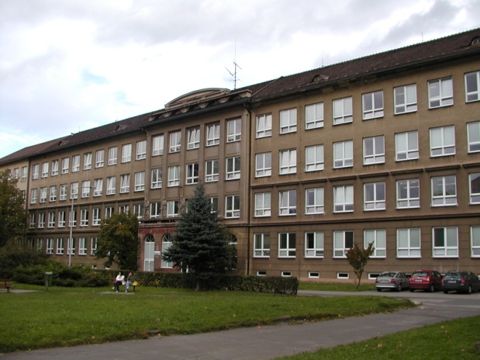

Zpracováno v rámci projektu

EU peníze školám

CZ.1.07/1.5.00/34.0296

Zpracovatel:  
**Mgr. Petra Bruková**

Gymnázium, Třinec, příspěvková organizace

Datum vytvoření: **leden 2013**

**Metodický list**

DUM opakuje získané znalosti o britských a amerických svátcích formou testu. Je zaměřen na názvy jednotlivých svátků, data konání a typické symboly. Poslední cvičení je věnováno procvičení krátkého slohového útvaru oznámení

v rozsahu 50 – 70 slov.

Součástí DUM je i řešení.

Inovativnost materiálu spočívá ve využití ICT techniky.

**REVISION – HOLIDAYS IN THE UK AND THE USA**

**1. Write the name of the holiday and the date when it is celebrated.**

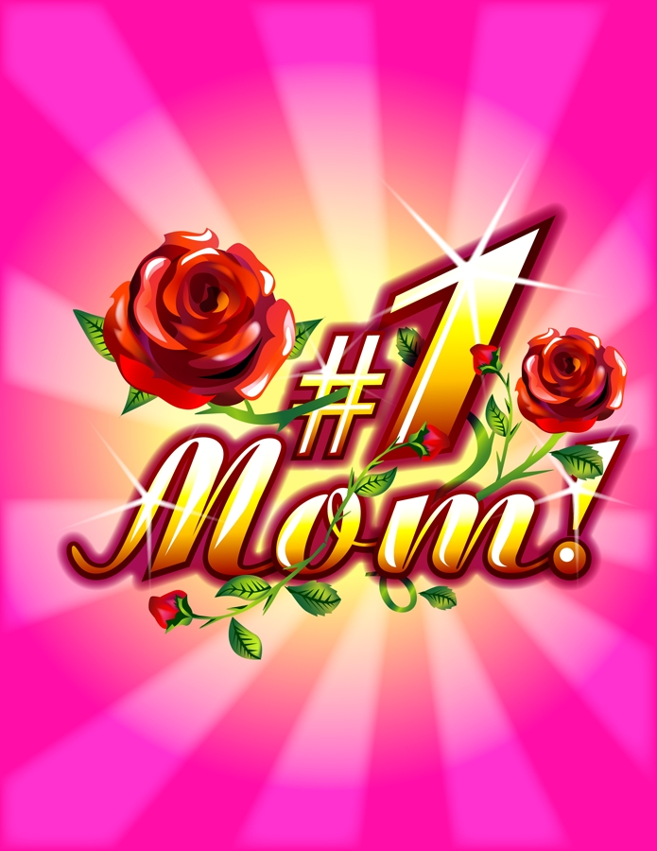

1. ……………… 2. ……………. 3. …………… 4. ……………. 5. ………….

……………… ……………. .…………… ……………. ………….



6. ………………. 7. ………………. 8. …………… 9. …………….. 10. ……………..

………………. ………………. …………... …………….. ……………..

**2. Choose the correct order of these celebrations from the beginning of the year to the**

**end of the year.**

1. New Year´s Day, Valentine´s Day, St. Patrick´s Day, Independence Day, Halloween, Thanksgiving Day, Christmas, New Year´s Eve
2. New Year´s Day, Valentine´s Day, Easter, Mother´s Day, Thanksgiving Day, Halloween, , Christmas, New Year´s Eve
3. New Year´s Day, Valentine´s Day, St. Patrick´s Day, Easter, Labour Day, Trooping the Colour, Remembrance Day, Christmas
4. New Year´s Day, Valentine´s Day, Easter, Trooping the Colour, Labour Day, Remembrance Day, Christmas Day, Christmas Eve, Boxing Day

**3. Figure out which holiday and food go together.**

1. We are having turkey, stuffing, cranberry sauce and potatoes with gravy. We usually watch parades on TV. What holiday are we celebrating?
   1. Thanksgiving
   2. St. Patrick´s Day
   3. Valentine´s Day

1. We are grilling chicken and ribs outdoors. We will have potato salad. Adults drink beer and children fruit punch. What are we celebrating?
   1. Easter
   2. Mother´s Day
   3. Memorial Day
2. We are going to prepare your favourite meal. And then we are going to serve a chocolate cake with candles. What are we celebrating?
   1. Your birthday
   2. New Year´s Day
   3. Valentine´s Day
3. We are having a picnic and we will have hot dogs or hamburgers and an apple pie. Then fireworks will start. What are we celebrating today?
   1. Halloween
   2. Independence Day
   3. Labour Day
4. We will have something red and in the shape of a heart. What are we celebrating

today?

* 1. Boss´s Day
  2. Mother´s Day
  3. Valentine´s Day

1. Today we are going to a pub to have some green beer. What could we be celebrating?
   1. Memorial Day
   2. St. Patrick´s Day
   3. Carnival
2. We will have hot cross buns and some hard boiled eggs. What holiday are we

celebrating?

* 1. Thanksgiving
  2. May Day
  3. Easter

1. We are going to have candies in the shape of ghosts, spiders or pumpkins. What are we celebrating today?
   1. Halloween
   2. New Year´s Day
   3. Your birthday

**4. Guess the character.**

1. I am a flying animal with a shiny, red nose.
2. I shoot an arrow to make people fall in love.
3. I come in my sleigh with nine reindeer.
4. I leave chocolate eggs for children in the gardens.
5. I made a lot of people happy because I married them.

**5. Write if the sentences are true or false.**

1. During Valentine´s Day you hang mistletoe over the door.
2. On April Fool´s Day people pull pranks on others.
3. On July 4 we can see fireworks in the sky.
4. Rosa Parks started selling poppies on Remembrance Day.
5. People wish each other ”A Happy Turkey Day” on December 25.

**6. Complete the names of the holidays to these expressions.**

1. reindeer …………………………………………
2. gunpowder …………………………………………
3. poppies …………………………………………
4. first harvest …………………………………………
5. eight-hour working day …………………………………………
6. catkins …………………………………………
7. anonymous cards …………………………………………
8. shamrock …………………………………………
9. apple bobbing …………………………………………
10. maypole …………………………………………

**7. Write an announcement for a Halloween party at your school. Give details about the date, time, place and a prize for the best costume. (50 – 70 words)**

.................................................................................................................................................................................................................................................................................................................................................................................................................................................................................................................................................................................................................................................................................................................................................................................................................................................................................................................................................................................................................................................................................................................................................................................................................................................................................................................................................................................................................................................................................................................................................



ŘEŠENÍ

**1. Write the name of the holiday and the date when it is celebrated.**

1. Veteran´s Day, the USA, November 11
2. Mother´s Day, the second Sunday in May
3. Valentine´s Day, February 14
4. Halloween, October 31
5. President´s Day, the third Monday in February
6. New Year´s Eve, December 31
7. birthday
8. Labour Day, May 1
9. Thanksgiving Day, last Thusrsday of November
10. Remembrance Day, November 11

**2. Choose the correct order of these celebrations from the beginning of the year to the**

**end of the year.**

a), c)

**3. Figure out which holiday and food go together.**

1. a 2. b 3. a 4. b 5. c 6. b 7. c 8. a

**4. Guess the character.**

1. Rudolph
2. Cupid
3. Santa Claus
4. Easter Bunny
5. Valentine

**5. Write if the sentences are true or false.**

a) F b) T c) F d) T e) F

**6. Complete the names of the holidays to these expressions.**

1. Christmas
2. Guy Fawkes´ Day
3. Remembrance Day
4. Thanksgiving Day
5. Labour Day
6. Easter
7. Valentine´s Day
8. St. Patrick´s Day
9. Halloween
10. May Day

**7. Write an announcement for a Halloween party at your school. Give details about the date, time, place and a prize for the best costume. (50 – 70 words)**

Students´ own answers.

Zdroje: kliparty společnosti Microsoft

text – archiv autora